**Making Better Rope**

**at the filament leveLL**

**“Great line! Great feel! Runs well!”**

John MacCausland – Star World Champion, America’s Cup Sailor

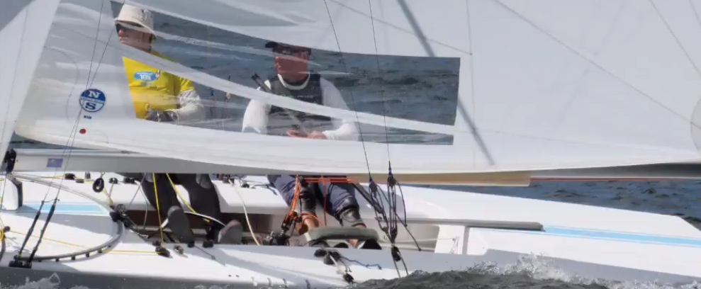

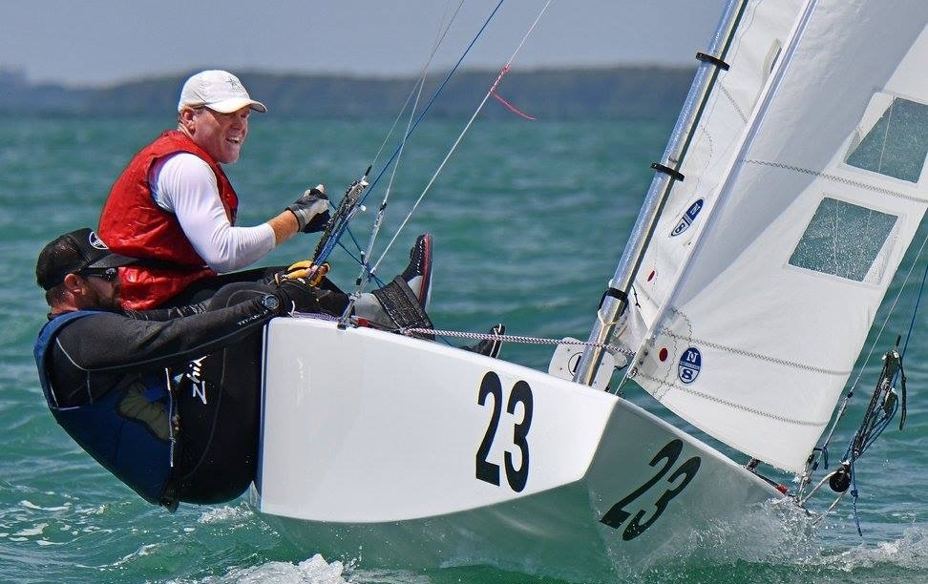

**“G&B Ropes is the highest quality line on the market today. We use their lines everywhere on our boat.”**

Eric Doyle – Star World Champion, America’s Cup Sailor

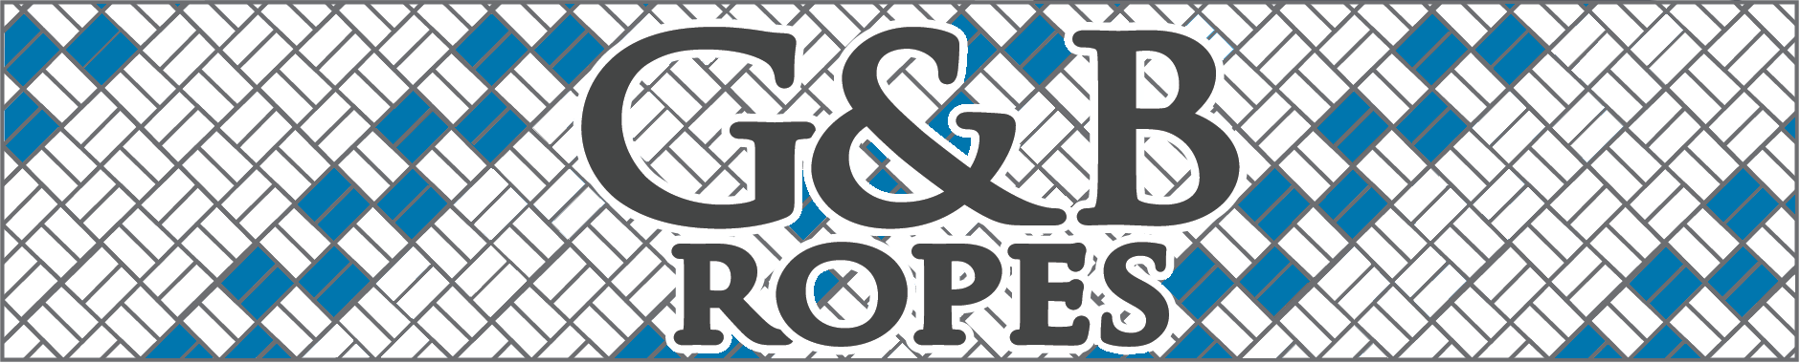





1-800-643-6350

**www.gbropes.com**

**266 Cambridge Rd W**

**Crystal Beach, Ontario**

**L0S 1B0 Canada**

**(905) 894-0035**

**200 Cornwall Ave**

**Buffalo, New York 14215 USA**

**(716) 842-0800**

**G&B Ropes**

**Research and Design**

Serving the industry for over 20 years, G&B Ropes has ensured high quality end products. Our lines only go market after extensive development by our engineers and on the water testing by some of the world’s top sailors.

Our raw materials undergo exhaustive and regular SPC testing before being allowed into production and G&B sources only first-grade materials.

G&B is currently beginning the extensive ISO certification process to ensure customers the best quality ropes.

|  |  |  |
| --- | --- | --- |
| **Product** | **Cover** | **Core** |
| SLS Yacht Braid | Polyester | Polyester |
| Mistral 78 | Polyester | AR-78 |
| Mistral 99 | Polyester | AR-99 |
| Mistral V | Polyester | AR-V |
| Mistral Tech Air | Poly/Technora | MFP |
| Mistral Tech 78 | Poly/Technora | AR-78 |
| Zephyr Air | MFP | MFP |
| Zephyr 78 | MFP | AR-78 |
| Zephyr D 78 | MFP/Dyneema | AR-78 |
| AR-78 | None | SK-78 |
| AR-99 | None | SK-99 |
| AR-V | None | Vectran |

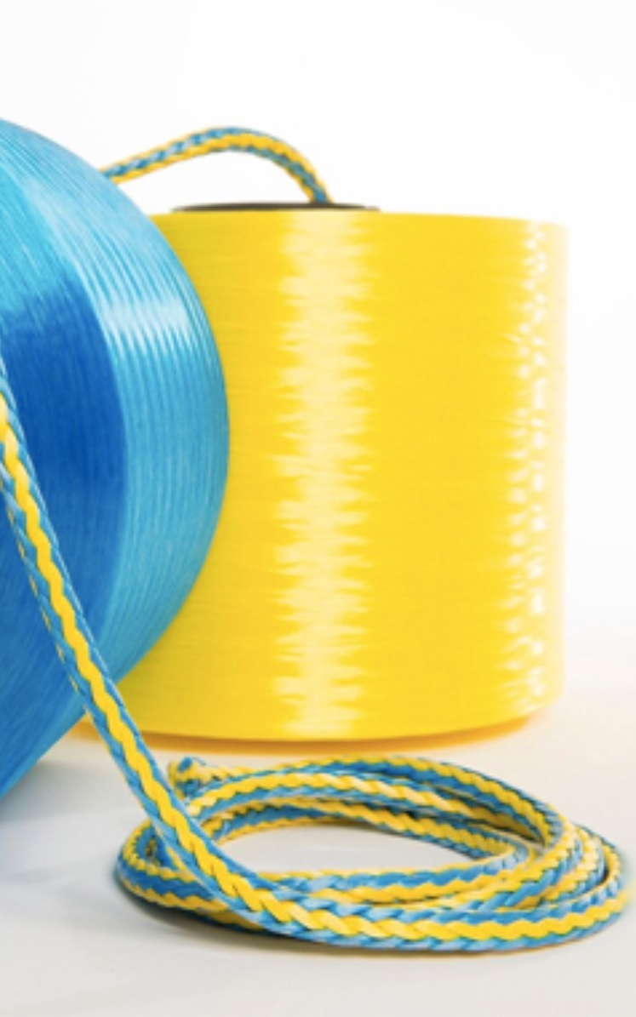

Rope Solutions™

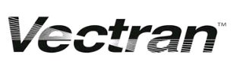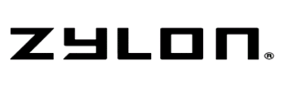

**Filament Coating = Better Rope**

G&B Ropes uses filament coated DSM Dyneema® and Vectran ™ in all single braids and high-tech rope cores. Filaments are coated after the extrusion process;at thefilament level.The coated filaments are then twisted to form the yarn for braiding. By coating the filaments, twisting, then braiding, the line is coated uniformly throughout the braided line.

**Benefits**

Coating high performance fibers at the filament level greatly enhances the durability and look of the line.

friction-coefficient

**Friction coefficient**

Reduction of the Coefficient of Friction leads to better Yarn-on-Yarn abrasion properties of the fiber yarn. This will significantly improve lifetime of a rope when internal abrasion or bending fatigue is the failure mechanism.

tensile-strength

**Tensile strength**

Rope efficiencies increase up to 20% by heat setting of rope yarns based on High Performance Fibers like Dyneema®, Vectran® or Technora®.

uv-resistance

**UV resistance**

UV resistance of Vectran® can be increased by applying filament coating technology. This significantly extends the lifetime of your halyard or single braid purchase system.

multicolor-rope

**Multicolor rope**

Applying different colored High Performance Fibers in a single rope not only makes for good aesthetics; they also have a functional use. It helps you to easily identify torque in a rope, which causes a significant reduction of tensile strength.

G&B offers filament coated Vectran ™, DSM Dyneema® SK-78, and DSM Dyneema® SK-99.

Whether using one of our cores in a double braid control line, sheets and halyards to be tapered, or as a single braid purchase system, you can be ensured that this industry leading technology will result in an improved overall line.

**AR-78 / AR-99 / AR-V**

**Core Technology**

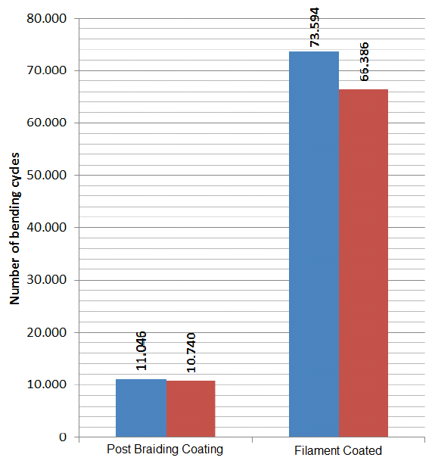

**Testing Data for Filament Coated Line**

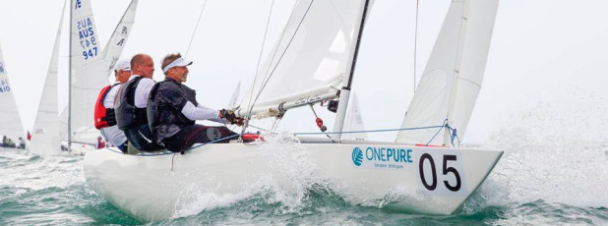

**“Lines look great and outperform anything we’ve used before.”**

Skip Dieball – Etchells World Champion

**Bend Fatigue Test:** Bend cycles of the filament coated line vs. the post-braiding coated line was over **6X better**.

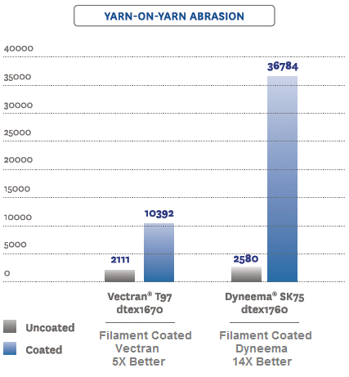

**AR-78 & AR-99**

**AR-78**

(SK78) High strength and better creep compared to SK75.

**AR-99:**

(SK99) 20% Stronger, excellent creep, unmatched strength to weight ratio.

**AR-V**

(Vectran™)Best creep performance and good resistance to heat compared to Dyneema®

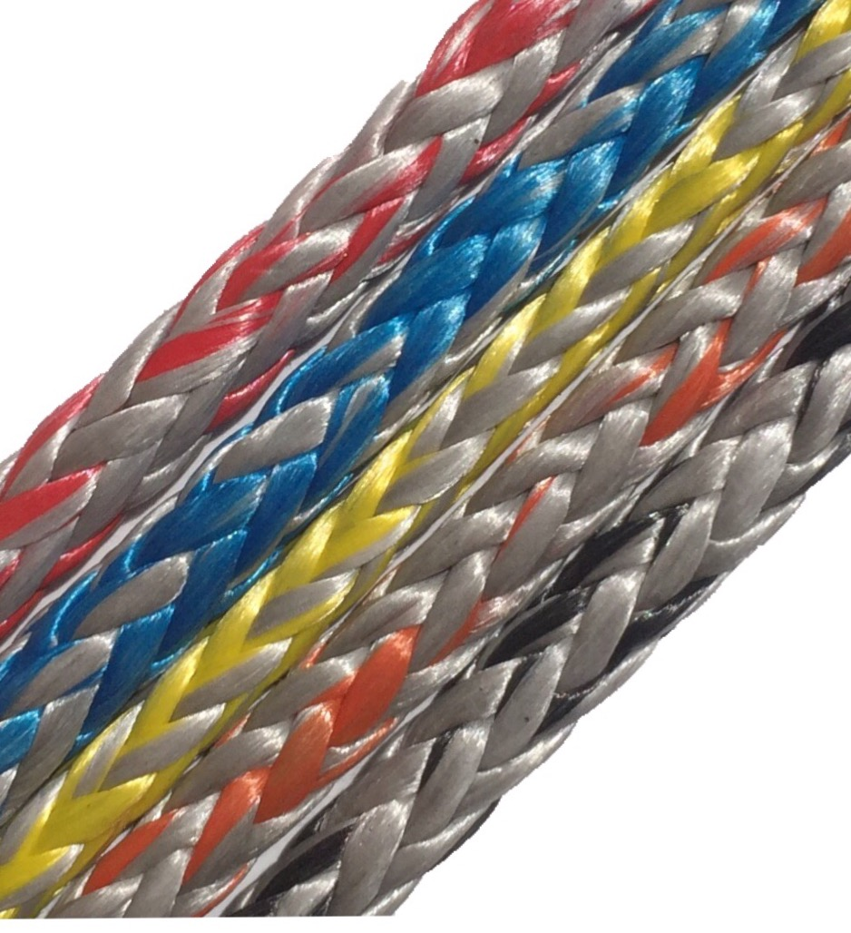

**Yarn-on-Yarn abrasion Test:** Filament coated Dyneema was **14x better** than uncoated and **5x better** with Vectran.

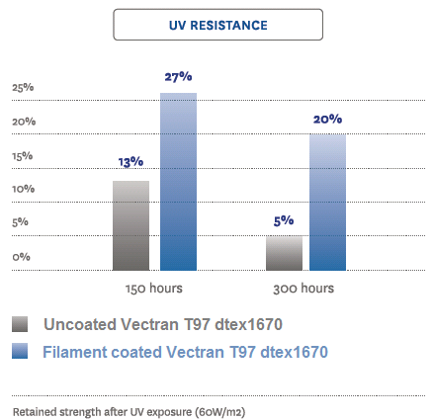

**AR-V**

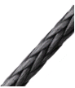

Visit **www.gbropes.com** for complete product descriptions and all that G&B Ropes can offer!

**UV Resistance Test:** Vectran UV resistance **2-4x Better**